**Course Outcome to be mentioned which is mapped with this lecture topic.**

CO5 :- To perform different operations on videos.

**Reading Material of this lecture topic.**

**Shooting and Editing Video**

Shooting a video is a continuous process. It’s all about the techniques and the instinct. If you want to shoot a normal video, chances are, you will end up adding pan, tilt, and zooming shots in your video. But this is not a bad habit to use these trios in the video, these common techniques can be used in almost every project. But there are some strategies to use it. To get the best possible result, you have to know how to use these effectively otherwise it will automatically yield a boring result.

Depending on the documentary or video, you may need to shoot on the fly “flowing the action” or everything may already be planned in advance. Different types of documentary or videos need a different set of actions for shooting. For example, if you are to shoot a historical documentary, you will need to shoot a lot of “talking head”.

With that said, you may think, to shoot a professional quality video you need expensive camera and gears. But the truth is, achieving a professional look is more about your technique than your tools, so no need to drop a fortune to buy expensive equipment right away. There is a good chance that you can make a great video with what you have at your disposal. What you actually need, is an amazing set of to-do-list/guidelines to guide you through the process of professional video shooting and editing. This article will provide exactly that.

**Tips for shooting professional looking video**

**Plan your shoot**

Ever wonder, why professional videos look so professional? If you take a close look at any professional video, you will see not only the video is well shot, but also well planned, in other word well directed. A kick-ass planning is what makes an idea to reality. So, before getting into real shooting, consider putting a storyboard and shooting script.

A storyboard helps you figure out exactly what you need to shoot and shooting script is like a screenplay for your video. You can use any kind of drawing, stick figuring or no drawing at all, you can use a still photograph or rough sketches whatever seems easy to you. Just make sure you have the plan in your hand before you start filming.

The deal is simple, the more time you spend planning and perfecting your film, the more it will look professional and less likely you are to find yourself missing footage later on.

**Camera Movement**

While shooting a video, movements of your camera determines what emotion needs to be evoked and what not. Camera movements give the filmmaker the ability to add drama, tension and other emotions to the scene. It also has the ability to direct the viewer’s attention towards a specific subject or action within the frame. But one thing to keep in mind that every movement that you generate must be intentional.

There are many kinds of camera movements used in professional cinematography. One of them is called hand-held movement. Suppose, you are to shoot a news event, where you track fast movement and fast moving objects or you are into documentaries where you need to move quickly. In all those scenarios it makes sense if you hold your camera in your hand. But where shaky footage is not the intention then using it may yield an unprofessional result.

In professional videography or cinematography, professionals use stabilized gimbal that carries the camera to stabilize the shot. In effect, it helps produce much cleaner and smoother looking image. In other words, it looks more professional. Sometimes those gimbals are expensive. So, instead what you can do, is to use a tripod where you can. It will make the image steady and make the viewer feel that they are observing the action.

**Camera Angle**

Different camera angles can add different value to the scene. Our perspective shifts as we change the angle of the camera. That means while shooting a video, with the angle change you can actually add different elements of your story to the scene, thus, you change how the viewers interpret a scene or story.

**Pan, Tilt and Zoom**

These three techniques are used for three different purposes. Panning is one of the oldest camera movement tricks of all time. It came from the word panorama. Pan is when you move your camera horizontally so that it sweeps around the scene. The main purpose of the pan is to capture the scene of action.

Tilting is another camera movement technique used to reveal something in the frame. It is often used with panning. Camera can be tilted up and down in a vertical panning shot or in a diagonal pan, as when it follows the subject.

When you need to intensify a situation and add some drama to the scene, apply zooming. This is the most widely used technique in all of the film industry. Combine this with the panning and the tilt and you get yourself the cleanest and professional looking video.

**Lighting**

Like photography, lighting is everything in videography. The same rule that applies to photography, applies to videography also. If not apply properly, light can actually ruin your whole photograph or in this case the video. Most common mistake that is done during shooting is to use either too much light or not enough light. Although you can fix the issue in post-production (to some extent), the end result will not be the cleanest. There will be unnecessary noise and grains all over the frame. Trust me, you really want to avoid that in the post-production.

To avoid that, never put your subject with their back to the sun or never put them under any kind of shade with a bright background. Whenever you are shooting, make sure your subject is well lit and ensure your primary light source is balanced and consistent. Try to shoot your video in a setup, avoid room with windows. Direct sunlight is very strong for any kind of shooting, in order to use it apply the art of diffusion. Learn to use defused light. It will serve you in the long run.

Another important thing is the white balance. Different light sources have different temperature and can affect the natural white balance of the scene. We need to account for these temperature ranges by manually set the cameras white balance. This is the way of telling the camera what “true white” looks like in an environment to avoid color casting. Many cameras have auto white-balance feature. But it is not recommended to use the camera’s auto function. Read your camera’s manual to learn how to do the white balance manually.

**B-Roll Footage**

If you are planning to intersperse your footage throughout the video or showcase the inner working of your product when filming the documentary then you need what professionals call B-Roll footage. B-roll is essentially any footage other than your primary subject. If you are filming a sports event then you might include the preparation activity as the B-roll footage or if you are filming a product explainer video showcasing your product, B-roll footage might include shots of satisfied customer using your product, or some external shot of your workplace.

It is wise to prepare the plan before you begin production. Figure out what you need to include in the production, do it in the pre-production to avoid situations in which you need footage you don’t have.

**Time Laps**

Time-lapse is one of the most fun and creative ways to show the flow of time. If used correctly, it can really boost the overall quality of the video that you want to make. What is beautiful about time lapse is that you can use it in any kind of storytelling video. It has the ability to add the extra oomph to the story. You can use it at the beginning of the video or at the end of the video or sometimes both. It depends on the creator and his intention behind it. When filming a documentary about the cosmos, you can use the low shutter to capture the whole Milky Way in a time lapse and use it as a B-roll.

Most of the camera nowadays has the time lapse feature built-in, you just have to access it from the menu. If not then just let it roll, you can always speed up the video in the post-production.

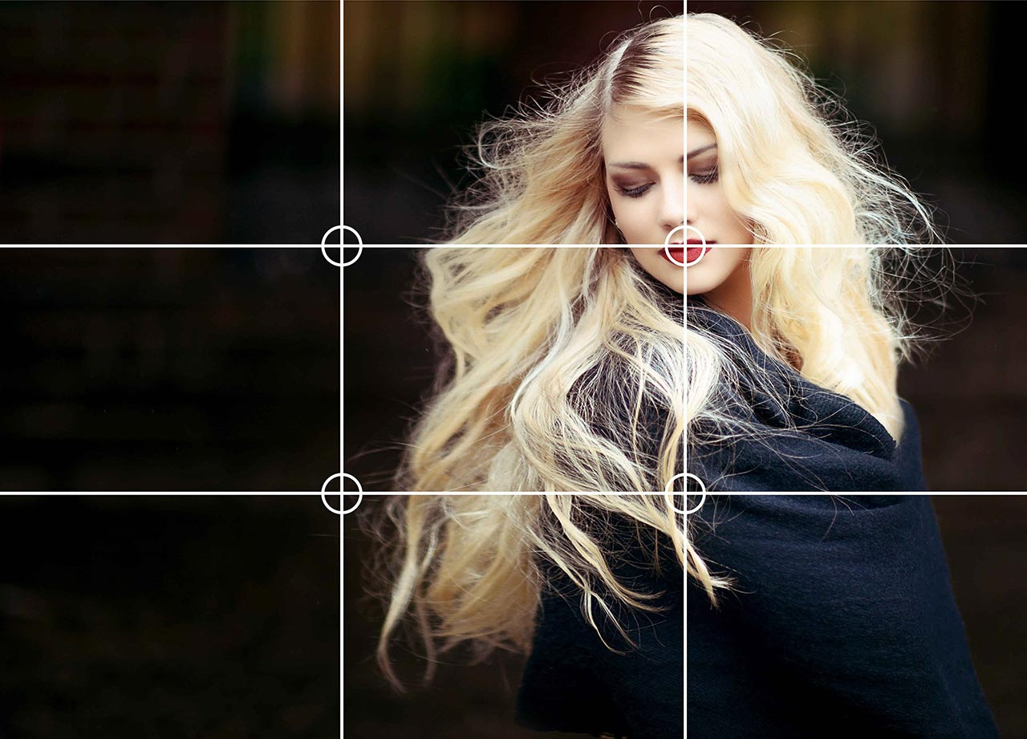

**Use the Rule of Third**

Rule of third is not only effective in photography but also effective in video also. While filming, frame it like a picture. This is where artistic expression comes into play, utilize the standard framing styles. Imagine your frame is divided into 9 equal parts. Two vertical lines and two horizontal lines. To apply rule of third, you need to place your subject in the two of the four intersected point (which are also called the “anchor point”). Sides doesn’t matter as long as you position your subject on the two intersected point or position your subject on the third most block, horizontally or vertically.

This technique is used to draw the attention of the spectator and draw the eyes towards the main point of the interest. The viewer’s eyes will naturally gravitate towards the leftmost corner or rightmost corner of the frame. When applied, this technique will separate the background from the foreground and give the spectator a cleaner look on the subject.

RELATED POST

1. [Top 5 Clipping Path Service Providers in the World](https://www.clippingpath.in/blog/top-5-clipping-path-services-in-the-world/amp/)
2. [Ultimate guide to start a successful wedding photography business](https://www.clippingpath.in/blog/guide-to-start-wedding-photography-business/amp/)
3. [Damaged photo repair service](https://www.clippingpath.in/blog/damaged-photo-repair-service/amp/)

**Shoot Multiple Takes**

It is always nice to have a safety net when you are shooting. Always remember, even experienced presenters make mistakes, and the last thing you want is a situation where you only have a single take of a crucial part of your video.

Make sure you have multiple takes of the same shoot. This will give you an extra room for error. If something goes wrong you will always have the other one to make an adjustment.

**Professional video editing tips**

After having all the necessary footage, you are now into the most exciting part of the movie-making process. Editing is a creative process and a whole new area of fun. This is where you fully unleash your creativity. However, it can be a daunting task, if you are new in the field. But the fact is, making a professional quality video is not that hard. You just need to learn basic cutting techniques and some creative ways to use it with sfx. So, without farther a due, let’s get started.

**Match Cut**

A match cut is similar to standard cut (cutting clips without any transition) but the difference is, when you cut the clips, the subject in both of the clips match. It gives a continuity to the scene and pushes it in a certain direction without misdirecting the viewers. A very basic example of a match cut would be to shoot someone opening a door from behind and then cutting to the opposite side as they walk through it. If done correctly, you can really create a captivating scene by just simply merging two similar looking clips. Probably the most famous example of these techniques can be seen in 2001: A Space Odyssey.

Example:  <https://youtu.be/mI3s5fA7Zhk>

**Jump Cut**

In this technique, you can cut a portion of time. With this cut, you can push forward in time. Smart use of this cut can really elevate the scene. Suppose you have a footage of unpacking some gadgets or something and it’s fairly long which can potentially make the viewers feel boring. In this case, you can use jump cut to avoid the boring staff and preserve the viewer’s interest. Watch how Casey uses jump cuts in his videos.

Example:  <https://www.youtube.com/watch?v=VBEqKYYF0-A>

**J and L cut**

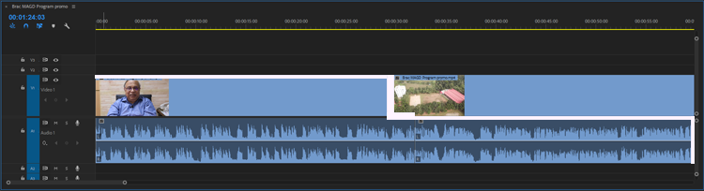

J and L cuts are in everything nowadays. Pretty much every interview and documentary take advantage of these cuts to tell a better story. These are like tying tools where j or l cut either overlaps audio or video onto the next scene.

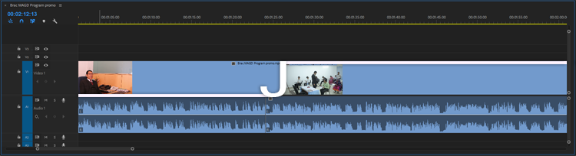

J cut happens when audio of clip A precedes the video of clip B. This is when you hear the sound first then the corresponding video. L cut happens when the audio of clip A succeeds the video of clip B. This is when you see the video first then the sound. Use of these techniques can add a lot of visual interest to the scene.

**Cutting on action**

All this mean is, cutting one shot to another while the subject is still in motion. This technique is used to drive more tension to the scene or add drama or thrill. It doesn’t always have to be on a punch or a kick, it could be something as simple as a character turning, throwing something or a character going through a door. The concept is simple, when you cut in the middle of an action, it will appear less jarring and more appealing. Cut when the subject is moving not when it completes the action.

Example: <https://www.youtube.com/watch?v=3pCs2Z6gMcE>

**Montage**

Montage is a technique used to show the passage of time. It signifies the transformation or character development that comes with time. So basically it helps giving an overall context to the story with quick cuts. It can be a training scene in a sport-related movie, it can be a flashback, often underscored with music. Montage is a very powerful technique, if used correctly it can add emotional value to a story.

Example: <https://youtu.be/DP3MFBzMH2o>

**Color correcting and color grading**

While editing a professional quality video, it is important to give your final footage a consistent color baseline. This is what color correction does in a video and in a photo. No matter how great your footage looks on set, you will always need to do some color correction in the post-production. Color is a huge manipulator, it can be used to manipulate the visual cortex of our brain and evoke a certain emotion.

Color grading, on the other hand, is actually the process of stylizing the footage to give your film a certain look. You can color grade your image with presets or by hand. There are a lot of presets out there for every major editing software. Presets are a good option when you are short on time but definitely not on par with the manual grading. But be careful when you use preset, preset tends to manipulate colors in wired ways, so you should scan through your footage for uneven color tone.

**Music and SFX**

Listening to a piece of music or a sound is one of those handfuls of activities that uses the whole brain to process. Sound plays a very important role with visuals. Along with the video, sound can create emotional tension or add drama to a scene. Many of the great filmmakers use specific sound to highlight key moments in the film. Specific sound can trigger specific emotions. So cartful use of music or sound can make a video rich, vibrant and premium.

In every professional quality videos, it is very common to see these techniques being used. If you want to maintain a consistent job of making quality videos, then these are the rules that you should always follow.

From bulk discounts to compact packages, we offer various benefits to our customers. Here at **Clipping Path India (CPI),** we offer the best video editing and motion graphics services. If you are a filmmaker then we can help you reduce all the post-processing burden and save you some of your valuable time. When it comes to video editing and motion graphics, you have our utmost dedication and promises. Promises to bring you the best services in this sector. Here is a list of advantages of choosing us over others, but this list is by no means is limited to the following.

* An experienced team of 200+ professionals for fashion apparels & accessory products
* We add or remove watermarks and are adept at adjusting brightness and reducing noise.
* We ensure complete data security and confidentiality of your pictures.
* Quick turnaround time
* Latest Cutting-edge technology
* Highly experienced and skilled professionals
* 24/7 customer support and assistance
* Competitive rates
* Proven methodologies to deliver quality services
* High volume discount
* Rush delivery service
* We produce 5000 image edits per day
* Simplified and competitive pricing based on work volume

**Clipping Path India (CPI)** has been providing best in class bulk photo editing services for the past 30 years. Throughout the experiences, we have learned, what our clients actually want in their finished product. With a perfect blend of experience, skills, dedication, and punctuality, we offer a wide range of image editing services which can assure you the perfect quality finished work. We have served more than 10,000 clients at both SME and Corporate level. Many new customers also turn to us for reliable image manipulation services. You don’t have to believe our words, try us and hit the [**Free Trial button**](https://www.clippingpath.in/free-trials/). If you are familiar and already convinced with our services then send us a [**Quote Request**](https://www.clippingpath.in/quote/) for our latest offerings.